COAXIAL EXTRUDER
The VDE-100 coaxial extruder is designed for nominal 1.75mm (millimeter) diameter fused deposition modelling filament. Modification of its dimensions make it easily useable for nominal 3.00mm filament. It is based upon the threadless leadscrew, and is mounted on the shaft of a stepper motor, which has been axially through bored and ballize polished to an internal diameter of 2.1mm.
The three industrial ABEC-5 extended inner race bearings are of 0.125 inch bore, a thickness of 0.172 inch, with an outside diameter of 0.3125 inch. The outer diameter of the flanged drive bearing is rotary ground to a diameter of 0.345 inch, at an included angle of 60 degrees. The bearings are inclined at an angle of 15.00 degrees perpendicular to their common center. The inclination of the bearings yields a mechanical advantage of 3.732:1, multiplied by the 5.714:1 ratio of the drive to filament diameters, for a final product of about 21.326:1. The bearings are shielded units running on precision shoulder screws, and are pre-loaded with Belleville springs to reduce backlash to that inherent to the bearings themselves.
The design allows for a diameter variation, with the same drive force, of a printer filament of +/-0.05mm from a nominal 1.75 mm diameter.
An interesting artifact of this design is that the pitch diameter of the driving knife edge varies with the diameter of the filament, so that greater lengths of smaller diameter filament are extruded, i.e., the design automatically corrects for volumetric extrusion based upon the filament diameter. While the relationship is necessarily not exact, it is within about 8% accuracy as regards extruded volume versus filament diameter. This property should be noted when calibrating the unit for steps per millimeter.
The external diameter of the extruder drive assembly may be knurled, so as to provide positive finger engagement through the access slots in the extruder groove mount adapter. This allows manual rotation of the extruder drive for filament loading and unloading without electrically engaging the stepper motor.
A 1.8 degree stepper with 16 microsteps (3200 microsteps per revolution), will have an extrusion resolution of 0.000294mm/microstep (294 nanometer, 3400 steps/mm), while a 0.9 degree stepper (6400 microsteps per revolution) will double that resolution (0.000147mm/microstep, or 147 nanometer).
Due to the mechanical advantage of the bearing lead angle, a NEMA 17 stepper of 11.6mm thickness is more than sufficient to extrude even at 680 mm³ per minute, or about 300 revolutions per minute. A NEMA 11 pancake stepper is also suitable, with an overall motor weight of less than 32 grams.
Additionally, the extruder assembly is extremely small and light weight, having a total mass of about 120 grams, inclusive of the heatsink and silver heat block, and dependent upon the material of construction. A Sanyo Denki SS2421-5041 NEMA 17 pancake stepper of 11.6 mm thickness has a mass of about 75 grams with leads, and a rated holding torque of 0.83 kg-cm. This is an equivalent extrusion force of about 17.5 kg (38 pounds) at the periphery of a 1.75 mm diameter filament.
Two of the bearings provide support for the filament. The third bearing is a flanged unit, with the flange rotary ground to a knife edge of 0.345 inch diameter and 60 degree included angle. It is important that the edge angle be symmetric so that extrusion and retraction will be equal. All bearings are shielded to prevent contamination from the printing environment.
The drive hub is printed from PLA, or cast/machined from aluminum alloy, either of which provides light weight and a pull out strength for the bearing shaft threads of about 90 pounds, or a roughly 2.25X safety factor. The motor shaft is clamped with a 4-40x3/16 inch set screw bearing upon the motor shaft.
Prototypes of the drive assembly and groove mount adapter were successfully printed during development using standard PLA filament, at 0.05mm and 0.1mm layer heights respectively, with 100% concentric infill. Threaded holes were hand tapped after printing using standard high speed steel gun taps, using printed and tapped guide bushings to ensure proper tap entrance planarity. Commonly available 4-40 or 3x0.5mm heat set inserts in the groove mount assembly allow rapid fastening of the drive motor.
The bearing shafts are 0.125 inch diameter precision shoulder screws with an ultra-low profile (3/64 inch) head 0.25 inch in diameter, and 4-40 threads. Standard 0.250x0.125 inch Belleville springs are placed under the head of each shoulder screw. These provide roughly 30 pounds of pre-load to the bearing inner race, without loading the rotating members of the bearings.
An acetal or polytetrafluoroethylene guide in the top of the heatsink immediately constraints the driven filament, so as to prevent potential buckling of flexible materials after exit from the coaxial drive.
An anti-torque assembly mounted to the top of the stepper uses a rotating follower to prevent axial rotation of the filament from torque forces during extrusion and retraction. However, during actual printing with PLA, PETG, and 95A TPU materials, there is sufficient adhesion of the filament within the nozzle that this anti-torque assembly is not necessary. It has subsequently been removed. The successful use of flexible filament was an unexpected bonus with this extruder design, particularly with no torque constraint other than the molten filament.
A NEMA 11 stepper of 9mm thickness (11HS04-0504S) is also suitable for low rate applications where mass is critical. This motor is rated for 0.5 amp, and must be driven at its rated current to establish reliable operation. Again, the shaft must be bored to 2.1mm, and the length trimmed to 5mm. For this design, a custom heat sink is screwed to an adapter designed for the application, and the total mass of the motor and drive assembly is 42 grams, when the bearing carrier is fabricated of 7075-Ts aluminum. A savings of 11 grams may be had by fabricating the carrier from PLA or other suitable plastic.
It is interesting to note that one adapter for the NEMA 11 design was printed in PLA at 0.005mm (5 micron) layer height. The print required 17.5 hours with a 0.4mm nozzle at 40mm per second and 100% concentric infill. Bridging was completely successful, which was surprising at these extremely low extrusion rates, and the resulting print had a velvet appearance, with no evidence of extruder drive cogging or other discernable printing surface artifacts, unlike a hobbed extruder.
Drawbacks to this general design are difficulty in removing filament without turning the motor shaft, although it is self-loading when the motor is rotating. Removing filament is best done by warming the nozzle to accomplish a cold pull, clipping the filament just above the motor, and then feeding the remaining filament until it clears the drive mechanism, with the motor and drive assembly removed from the mounting adapter.
Additionally, the coaxial design requires that the motor shaft be axially bored to allow passage of the driven filament to the drive assembly.
It should also be noted that this approach to filament extrusion was made in an attempt to reduce moving mass on the effector of a delta printer. The objectives were low mass, extreme repeatability of extrusion and retraction, and absence of printed surface artifacts attributable to gear drives or toothed drive hobs. Additionally, the extruder would be easy and inexpensive to repeatably replicate. All of these objectives have been achieved. However, it should be noted that this is not the extruder for fast prints with large nozzles.
The final implementation settled on Imperial dimensioned bearings of 5/16” nominal outside diameter, with extended inner races of 0.172” thickness, and using 1/8” diameter, ultra-low profile precision shoulder screws for the 1/8” bores. This loosens the tolerances required for the bearing clearance, eliminates three of the Belleville springs, eliminates “tuning” of the shoulder screw and Belleville spring diameters for clearance, reduces the need for extreme tolerance on the grinding of the flanged bearing knife edge, establishes commonality of bearing and shoulder screw dimensions, and makes assembly completely trivial. The only objection to this approach is that full ceramic bearings are generally not available with extended inner races, should the savings in weight, and the extreme hardness of a ceramic knife edge, be desired.
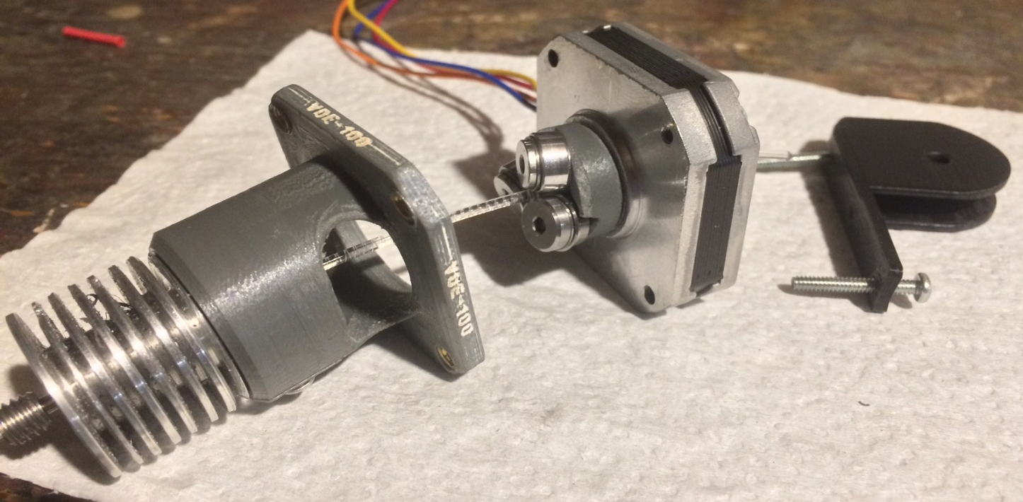
VDE-100 COAXIAL EXTRUDER SHOWING (LEFT TO RIGHT): TRI-METAL HEATBREAK, HEATSINK, GROOVE MOUNT ADAPTER, DRIVE ASSEMBLY, NEMA 17 PANCAKE STEPPER, ANTI-TORQUE HOUSING (roller and bearing not shown), CLEAR PETG FILAMENT WITH VISIBLE DRIVE ROLLER IMPRESSION
TOTAL WEIGHT 120 GRAMS
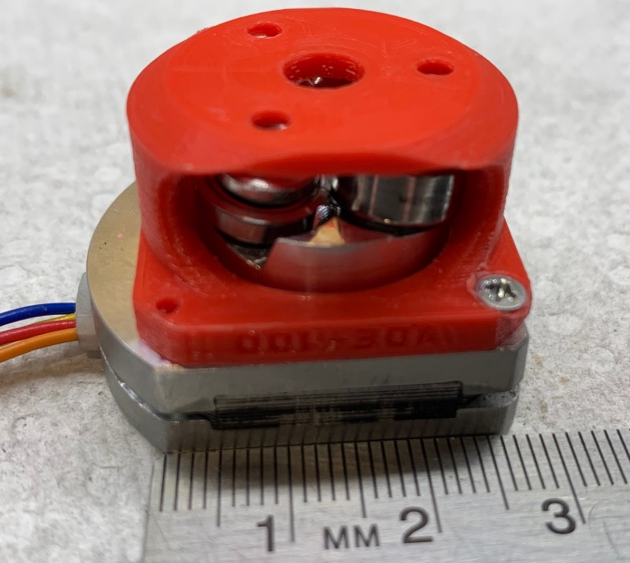
NEMA 11 VDE-100 WITH 7075 ALUMINUM DRIVE CARRIER AND PETG ADAPTER
WEIGHT AS SHOWN 42 GRAMS, MOTOR IS 28 GRAMS

