Syringe Carriage
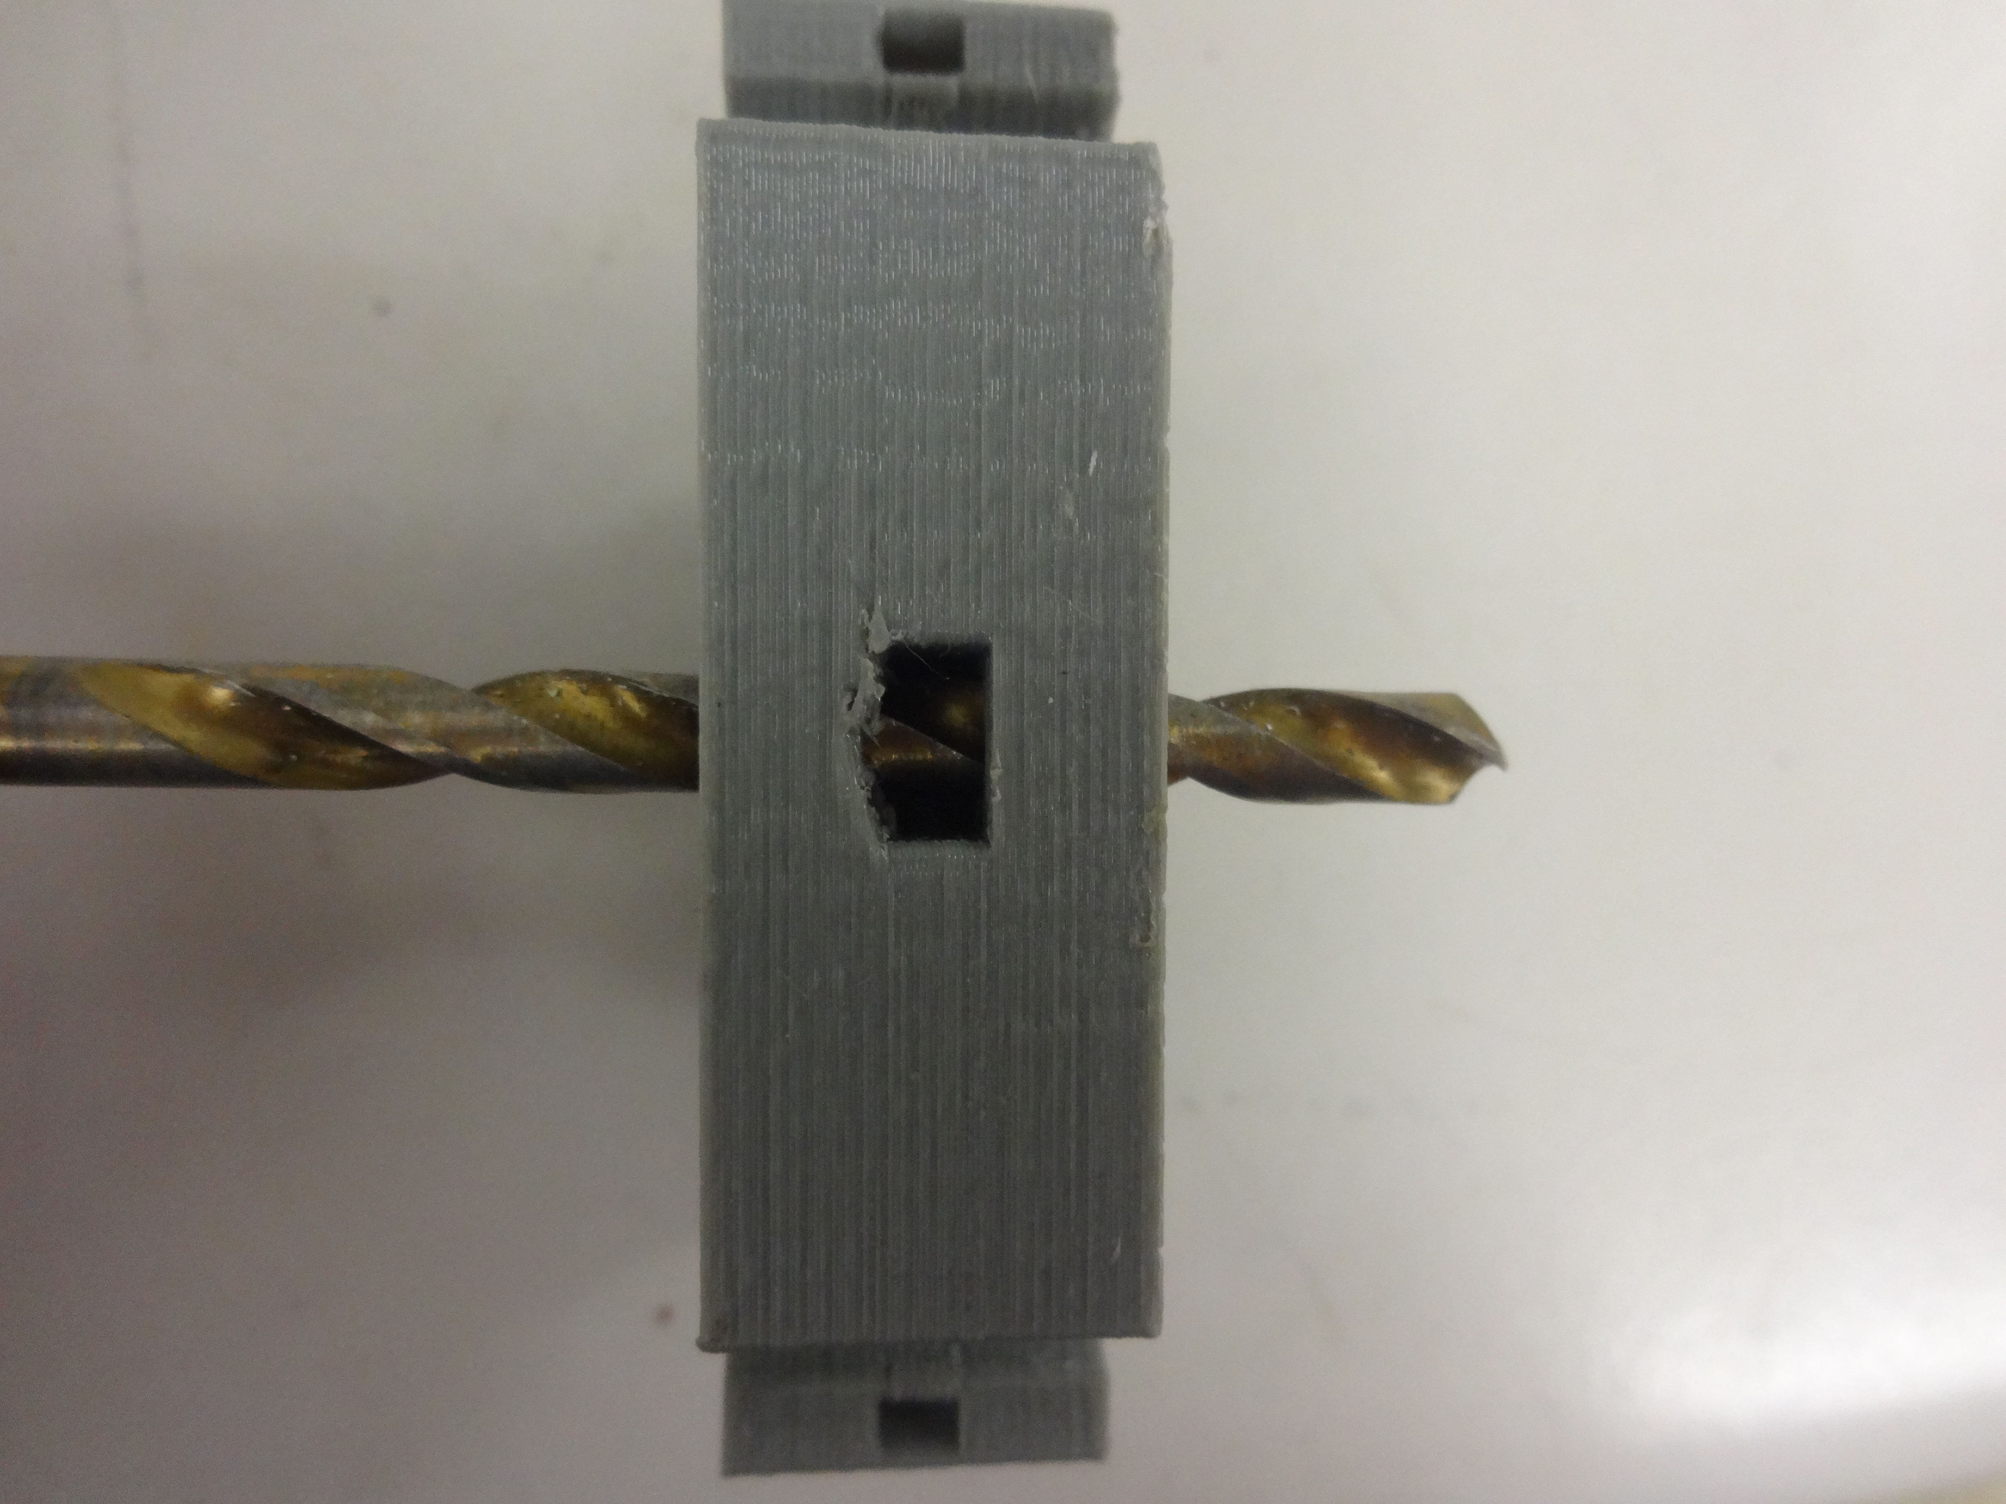Fig 1: Reaming Out the Threaded Rod Hole
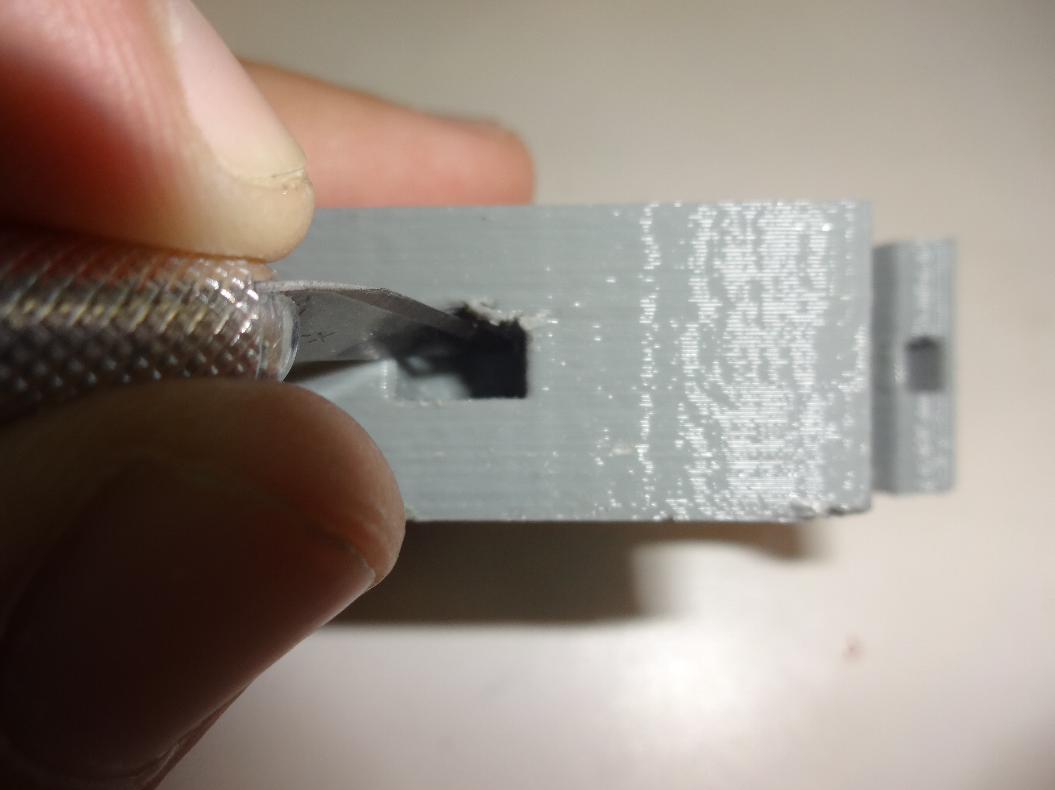Fig 2: Cleaning Out the Top of the Nut Trap

1) Using a 5mm drill bit, ream out the threaded rod hole(Figure 1)

2)Take a sharp knife and cut off any loose strands of plastic on the top of the nut trap.

