Motor
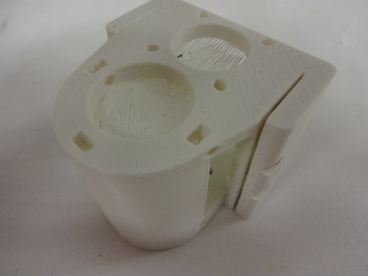Fig 1: Motor Assembly before prep

1) Using a sharp knife, take the motor end, and clean out the support material in the motor hole and the Syringe Hole. (Figures 2 & 3)
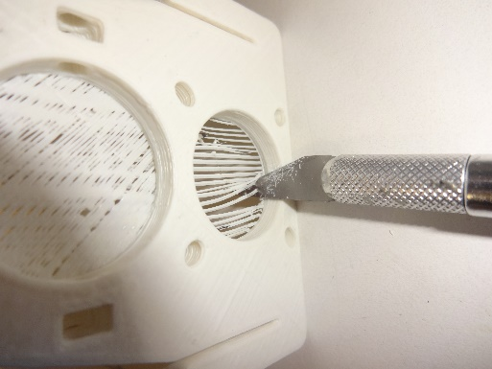Fig 2: Cleaning the Motor Hole

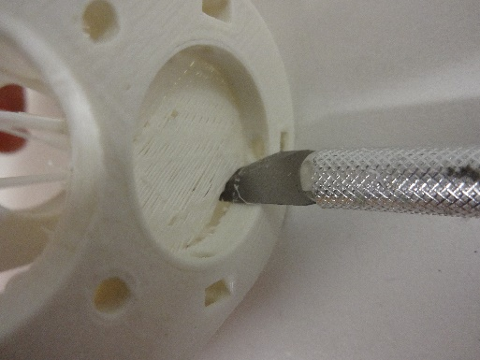Fig 3: Cleaning the Syringe Hole

2) Still using a sharp knife, begin cutting out the bottom of the support material around the bottom of the Syringe Hole (Fig 4) and repeat at the top (Figure 5).

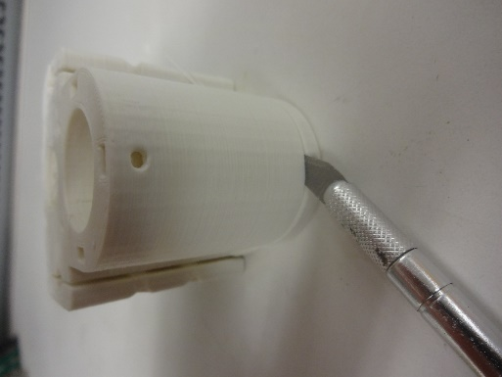
Fig 4: Cutting out the bottom of the support material

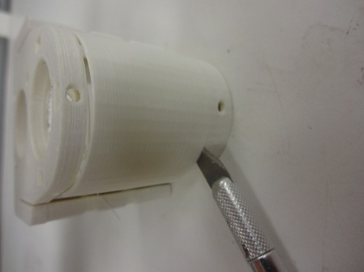
Fig 5: Cutting out the support material

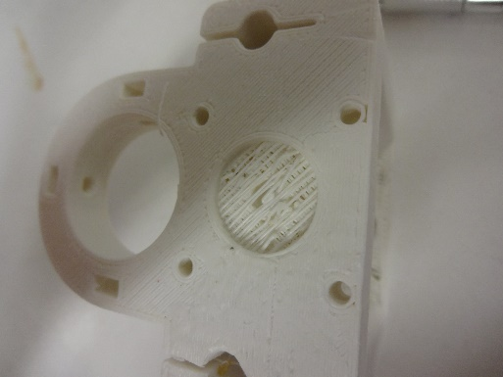Fig 6: Threaded Rod Hole before cleaning
3) Then clean out the support material in the threaded rod hole using a sharp knife or a 5 mm drill bit. (Figures 6 & 7)
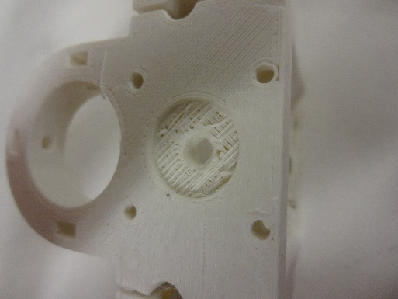Fig 7: Threaded Rod Hole after cleaning
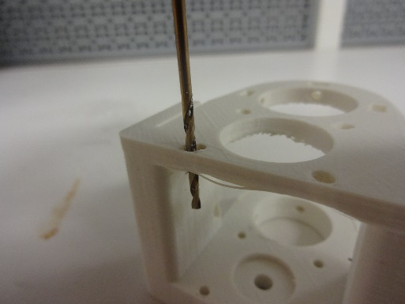Fig 8: Reaming out the Motor Screw Holes
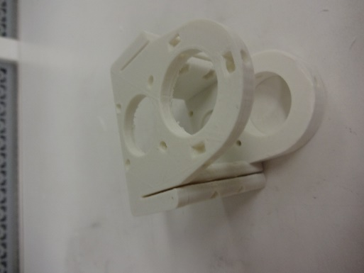
4) Using a 2.5 mm drill bit, ream out the screw holes for the motor. All four screw holes should be cleaned. (Figure 8 &9)
Fig 10: Cleaned Motor Assembly
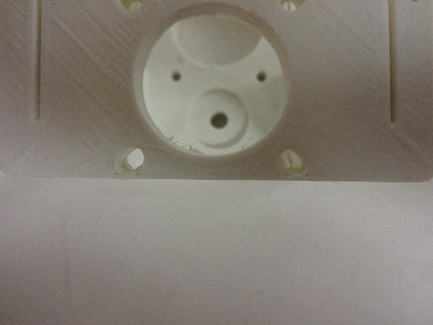Fig 9: Clean Screw Hole (Left), Uncleaned Screw Hole (Right)

